ROCKBUSTER DATA DICTIONARY

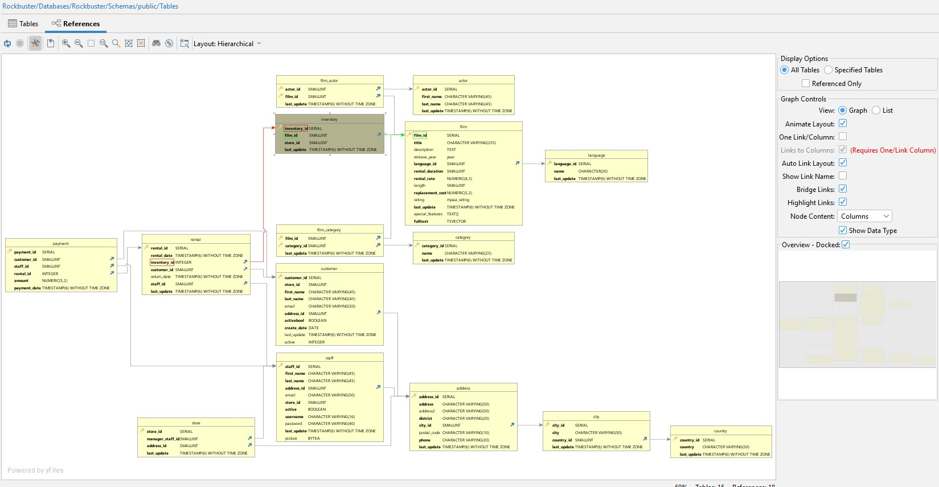

Contents

Fact Tables: 1

Payment 1

Dimension Tables: 2

Film_actor 6

Actor 6

Film 7

Category 8

Address 8

Language 8

City 9

Country 9

# Fact Tables:

|  |  |  |  |  |  |
| --- | --- | --- | --- | --- | --- |
| Table name | name |  | Columns | Data Type | Description |
| Payment | | Payment_id | SERIAL | Payment ID |
| customer_id | SMALLINT | Customer ID |
| Table p-key | Payment_id | staff_id | SMALLINT | Staff ID |
| Table foreign key | customer_id  staff_id  rental_id | rental_id | INTEGER | Rental ID |
| Table from | x | amount | NUMERIC (5,2) | Amount of money |
| Table to | rental, customer, staff | payment_date | TIMESTAMP(6)  WITHOUT TIME ZONE | Payment date and  time |

|  |  |  |  |  |  |
| --- | --- | --- | --- | --- | --- |
| Table name | name |  | Columns | Data Type | Description |
| Rental | | rental_id | SERLIAL | Rental ID |
| rental_date | TIME STAMP (6)  WITHOUT TIME ZONE | Rental date and time |
| Table p-key | Rental_id | inventory_id | INTEGER | Inventory ID |
| Table foreign key | Inventory_id,customer_id,staff_id | customer_id | SMALLINT | Customer ID |
| Table from | Payment | return_date | TIME STAMP (6)  WITHOUT TIME ZONE | Return date and time |
| Table to | Inventory, customer, staff | staff_id | SMALLINT | Staff ID |
|  |  | last_update | TIMESTAMP (6)  WITHOUT TIME ZONE | Last update Date and  time |

# Dimension Tables:

|  |  |  |  |  |  |
| --- | --- | --- | --- | --- | --- |
| Table name | name |  | Columns | Data Type | Description |
| Store | |  | store_id | SERIAL | Store ID |
| Table p-key | Store_id |  | manager_staff_id | SMALLINT | Manager staff ID |
| Table foreign key | Manger_staff_id, address_id |  | address_id | SMALLINT | Address ID |
| Table from | X |  | last_update | TIMESTAMP (6) WITHOUT TIME ZONE | Date and time last update |
| Table to | Staff, address |  |  |  |  |

|  |  |  |  |  |
| --- | --- | --- | --- | --- |
| Table name | name | Columns | Data Type | Description |
| Staff | | staff_id | SERIAL | Staff ID |
| Table p-key | Staff_id | first_name | CHARACTER  VARYING(45) | First name |
| Table foreign key | Address_id | last_name | CHARACTER  VARYING(45) | Last name |
| Table from | Payment, rental, store | address_id | SMALLINT | Address ID |
| Table to | address | email | CHARACTER  VARYING(50) | Email address |
|  |  | store_id | SMALLINT | Store ID |
|  |  | active | BOOLEAN | active |
|  |  | username | CHARACTER  VARYING(16) | Username |
|  |  | password | CHARACTER  VARYING(40) | Password |
|  |  | last_update | TIMESTAMP (6)  WITHOUT TIME ZONE | Date and time last  update |
|  |  | picture | BYTEA | picture |

|  |  |  |  |  |
| --- | --- | --- | --- | --- |
| Table name | name | Columns | Data Type | Description |
| Customer | | customer_id | SERIAL | Customer ID |
| Table p-key | customer_id | store_id | SMALLINT | Store ID |
| Table foreign key | Address_id | first_name | CHARACTER VARYING  (45) | First name |
| Table from | payment | last_name | CHARACTER VARYING  (45) | Last name |
| Table to | address | email | CHARACTER VARYING  (50) | Email address |
|  |  | address_id | SMALLINT | Address ID |
|  |  | activebool | BOOLEAN | Acrivebool |
|  |  | create_date | DATE | Date |
|  |  | last_update | TIMESTAMP (6)  WITHOUT TIME ZONE | Date |
|  |  | active | INTEGER | active |
|  |  |  |  |  |

|  |  |  |  |  |
| --- | --- | --- | --- | --- |
| Table name | name | Columns | Data Type | Description |
| Film_category | | film_id | SMALLINT | Film ID |
| Table p-key | film_id, category_id | category_id | SMALLINT | Category ID |
| Table foreign key | x | last_update | TIMESTAMP (6)  WITHOUT TIME ZONE | Date and time last  update |
| Table from | x |  |  |  |
| Table to | Film, category |  |  |  |

|  |  |  |  |  |
| --- | --- | --- | --- | --- |
| Table name | name | Columns | Data Type | Description |
| Inventory | | inventory_id | SERIAL | Inventory ID |
| Table p-key | inventory_id | film_id | SMALLINT | Film ID |
| Table foreign key | film_id | store_id | SMALLINT | Store ID |
| Table from | Rental | last_update | TIMESTAMP (6) WITHOUT TIME ZONE | Date and time last update |
| Table to | film |  |  |  |

|  |  |  |  |  |
| --- | --- | --- | --- | --- |
| Table name | name | Columns | Data Type | Description |
| Film_actor | | actor_id | SMALLINT | Actor ID |
| Table p-key | actor_id, film_id | film_id | SMALLINT | Film ID |
| Table foreign key | x | last_update | TIMESTAMP (6)  WITHOUT TIME ZONE | Date and time last  update |
| Table from | x |  |  |  |
| Table to | Actor, film |  |  |  |

|  |  |  |  |  |
| --- | --- | --- | --- | --- |
| Table name | name | Columns | Data Type | Description |
| Actor | | actor_id | SERIAL | Actor ID |
| Table p-key | Actor_id | first_name | CHARACTER VARYING  (45) | First name |
| Table foreign key | X | last_name | CHARACTER VARYING  (45) | Last name |
| Table from | Film_actor | last_update | TIMESTAMP (6)  WITHOUT TIME ZONE | Date time lasts update |
| Table to | x |  |  |  |

|  |  |  |  |  |
| --- | --- | --- | --- | --- |
| Table name | name | Columns | Data Type | Description |
| Film | | film_id | Serial | Film ID |
| Table p-key | film_id | title | Character Varying  (255) | Title |
| Table foreign key | language_id | description | TEXT | Description |
| Table from | film_category,inventory film_actor | release_year | Year | Year of release |
| Table to | language | language_id | SMALLINT | Langauage ID |
|  |  | rental_duration | SMALLINT | Rental duration |
|  |  | rental_rate | NUMERIC (4,2) | Rental rate amount |
|  |  | length | SMALLINT | Movie length |
|  |  | replacement_cost | NUMERIC(5,2) | Replacement cost  amount |
|  |  | rating | Mpaa_rating | Rating |
|  |  | last_update | TIMESTAMP (6)  WITHOUT TIME ZONE | Date and time last  update |
|  |  | special_features | TEXT[] | Special features |
|  |  | fulltext | TSVECTOR | Full text |

|  |  |  |  |  |
| --- | --- | --- | --- | --- |
| Table name | name | Columns | Data Type | Description |
| Category | | category_id | SERIAL | Category ID |
| Table p-key | category_id | name | CHARACTER  VARYING(25) | Name |
| Table foreign key | x | last_update | Timestamp(6)  WITHOUT time zone | Date and time last  update |
| Table from | film_category |  |  |  |
| Table to | x |  |  |  |

|  |  |  |  |  |
| --- | --- | --- | --- | --- |
| Table name | name | Columns | Data Type | Description |
| Address | | address_id | SERIAL | Address ID |
| Table p-key | address_id, | address | CHARACTERS  VARYING (50) | Addres main |
| Table foreign key | city_id | address2 | CHARACTERS  VARYING (50) | Secondary address |
| Table from | Store, staff, custsomer | district | CHARACTERS  VARYING (20) | District |
| Table to | city | city_id | SMALLINT | City ID |
|  |  | postal_code | CHARACTERS  VARYING (10) | Postal code |
|  |  | phone | CHARACTERS  VARYING (20) | Phone number |
|  |  | last_update | TIMESTAMP (6)  WITHOUT TIME ZONE | Date and time last  update |

|  |  |  |  |  |
| --- | --- | --- | --- | --- |
| Table name | name | Columns | Data Type | Description |
| Language | | language_id | SERIAL | Language ID |
| Table p-key | language_id | name | CHARACTER (20) | Name |
| Table foreign key | x | last_update | TIMESTAMP (6)  WITHOUT TIME ZONE | Date and time last  update |
| Table from | film |  |  |  |
| Table to | x |  |  |  |

|  |  |  |  |  |
| --- | --- | --- | --- | --- |
| Table name | name | Columns | Data Type | Description |
| City | | city_id | SERIAL | City ID |
| Table p-key | city_id | city | CHARACTERS  VARYING (50) | city |
| Table foreign key | country_id | country_id | SMALLINT | Country ID |
| Table from | address | last_update | TIMESTAMP (6)  WITHOUT TIME ZONE | Date and time last  update |
| Table to | country |  |  |  |

|  |  |  |  |  |
| --- | --- | --- | --- | --- |
| Table name | name | Columns | Data Type | Description |
| Country | | country_id | SERIAL | Country ID |
| Table p-key | country_id | country | CHARACTER VARYING  (50) | Country name |
| Table foreign key | x | last_update | TIMESTAMP (6)  WITHOUT TIME ZONE | Date and time last  update |
| Table from | city |  |  |  |
| Table to | x |  |  |  |